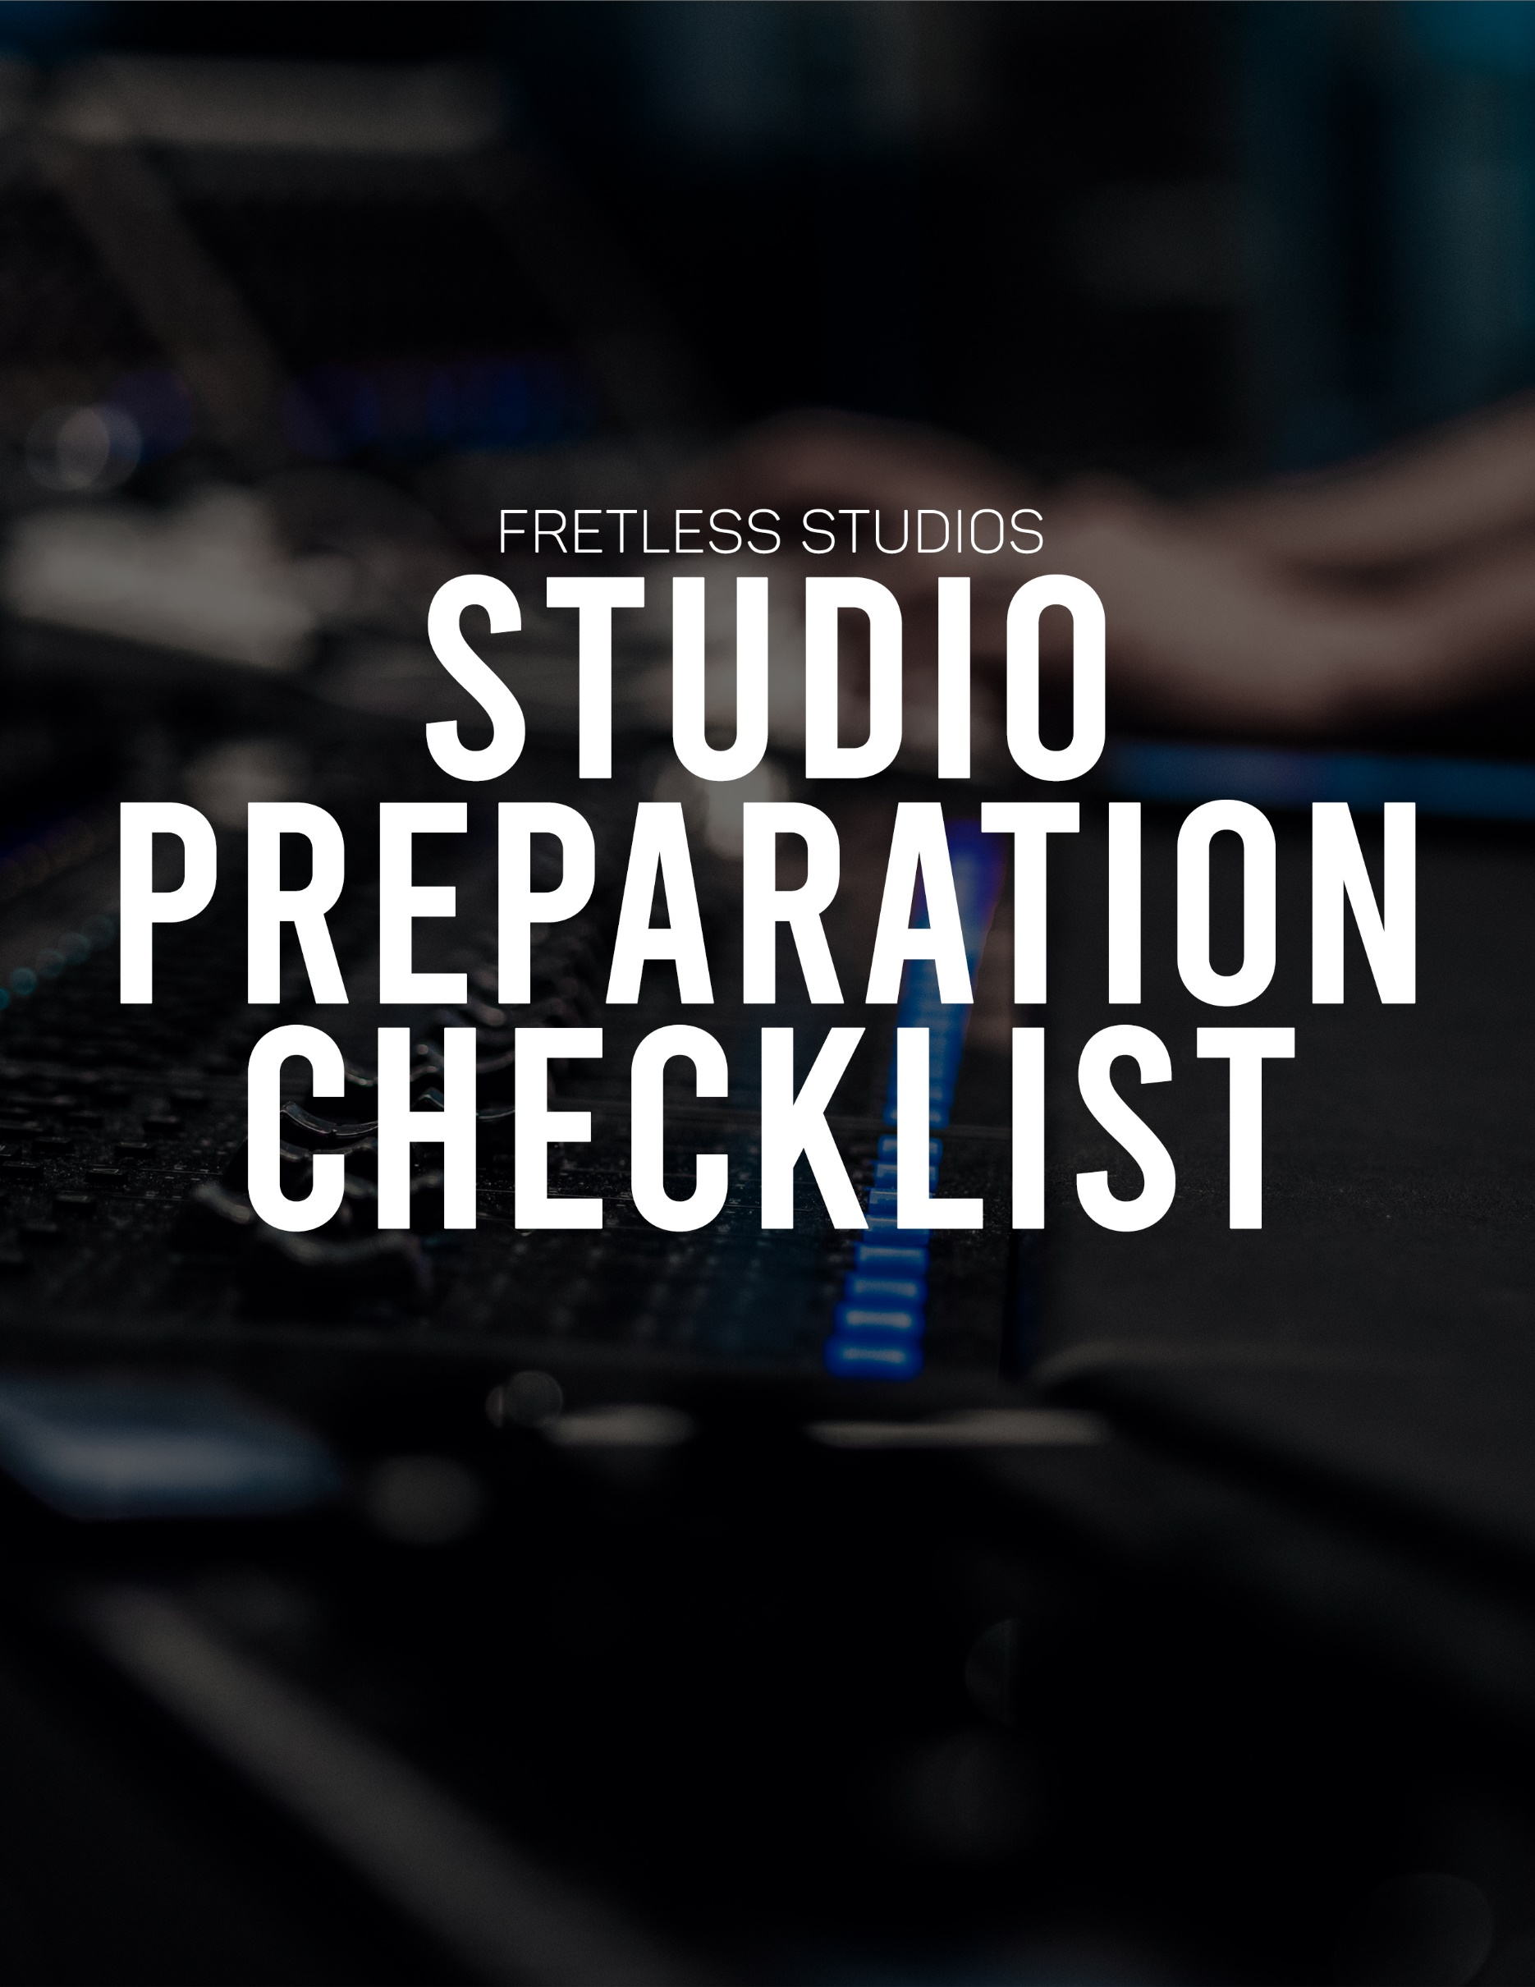
Studio Prep:
Before Contacting The Studio:
☐  ☐  ☐  ☐  ☐  ☐  ☐  ☐  ☐  ☐  ☐ | Is the song ready to record?  Does the song have a purpose and does it serve its purpose?  Have you recorded a practice and listened back to make any critiques?  Have you practiced without mistakes 5 times in a row?  Have you practiced with metronome?  Have you explored at least 3 different routes for  improv (different scale, technique, way of thinking, etc)?  Is your solo fully written out based on above?  Is the song well thought-out and intentional at every point  for all parts?  Does the songwriting have good contrast in instrumentation,  sections/arrangement, etc?  What are the three most important things you want achieved  out of this session, and did you let the engineer and bandmates know?  Do you have reference tracks for what you want your project  to sound like?  Do your bandmates know their part as much as you know yours?  ☐  ☐  ☐  ☐  ☐  ☐  ☐  ☐  ☐  ☐  ☐  ☐  ☐  ☐  ☐  Is the tempo set in stone?  Can you record a scratch track with a metronome at home?  Can you record a demo to help you, your bandmates, and the engineer?  If capable, can piano parts be recorded as MIDI at home and sent  to the engineer for recording day?  MIDI tempo mapped the song?  Give the engineer the titles of all the songs with their tempo?  If you're bringing samples/beats to the session, are they cleared to use legally?  Are the samples/beats at least .wav at 44.1kHz sample rate and 16 bit depth?  Need to rent a piece of equipment?  Need to hire a session player?  Is the cover art planned out? Photo or video content for the release?  Post release? Pre-release?  Are you able to cover the project fully financially?  Have you collected your bandmate's share of the total project  cost and not just as promised?  Vocalists:  Is your schedule clear of any singing gigs the week before  the session and during?  Have you written your harmonies beforehand?  Have you practiced your written harmonies?
☐
☐
Night Before/Leaving for the Studio:
☐  ☐  ☐  ☐  ☐  ☐  ☐  ☐  ☐  ☐  ☐  ☐  ☐  ☐  ☐  ☐  ☐ | Are you well rested/in a good place to record the best  performance you can?  Does everyone know when and where to be?  Does anyone need to leave early and is that taken into account?  If taking the session files for mixing/mastering elsewhere, do you  have a usb/hard drive capable of holding the sessions? (Probably  around 10-15GB per song to be safe)  Do you know what the day/week will look like in terms of order/etc?  Plan for breakfast/lunch/dinner/breaks?  Strings changed the night before and stretched out?  Bring an extra pack of strings incase the new strings break?  Are your drum heads relatively new?  Are you wearing quiet clothing? (no rattling, scrapping, jingling sounds)?  Are you bringing a notepad and pencil for notes on takes or miscellaneous?  Are you bringing a source of (quiet) entertainment like listening to  music or watching a tv show (both with headphones) while others  are recording?  Do you have a checklist marked off for all the gear you are bringing  and need?  Vocalists:  Is your schedule clear of any singing gigs the week before the  session and during?  Are you bringing lyrics before the session starts for you and the engineer?  Do you have a warm drink like warm water or tea with honey to  soothe your throat? (nothing that will make your mouth and  throat sticky!)  Have you avoided smoking and drinking prior to session?

Tips To Keep In Mind:
Try not to change settings between takes (volume, treble knob on amp, tone knob on guitar, etc) unless the engineer knows/gives the go ahead. This allows the engineer to stay organized and be able to edit takes while making it seem like a natural one take!

