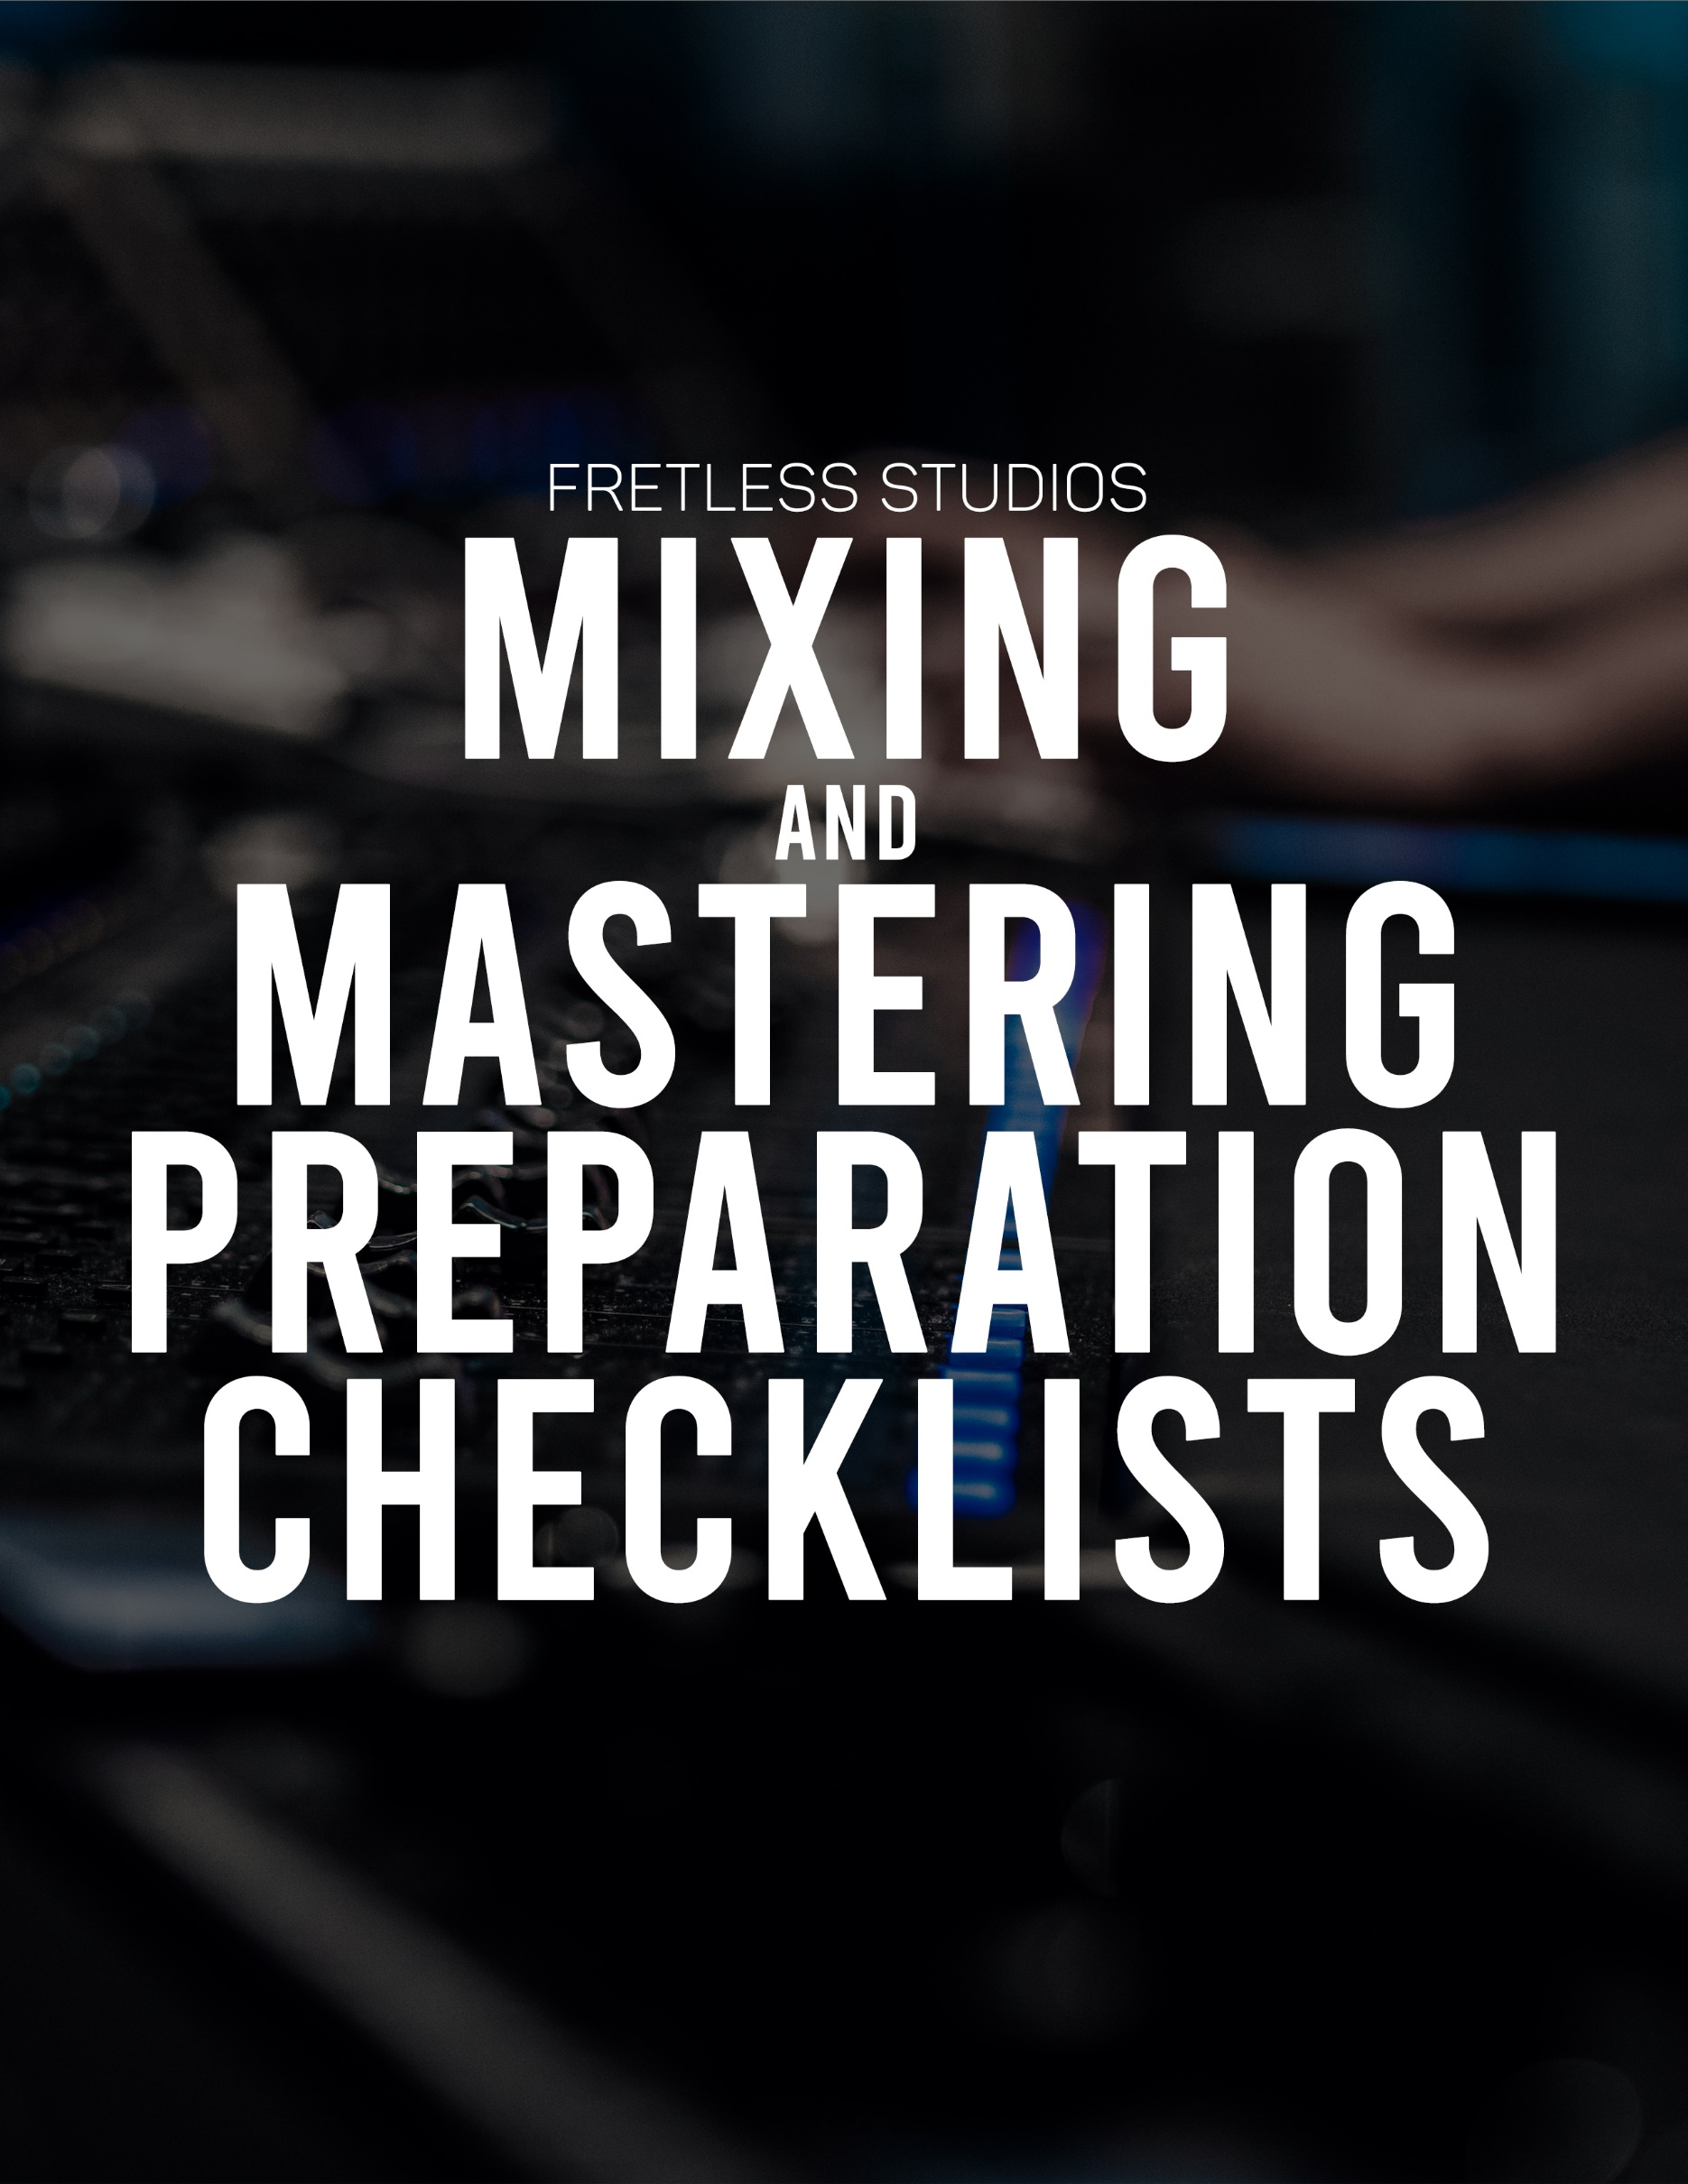

Mixing:

|  |  |
| --- | --- |
|  | Are all tracks edited, comped, and tuned completely? (Unlesstuning requested)Are all tracks are free of editing clicks, pops, glitches, noticeablecrossfades, etc?Are all tracks free of clipping and distortion?Do all files start at the same time and are continuous? (ie, the fileswill play at the right time when lined up at the start and isone clip per track?)Do all tracks have little to no processing on them unless they areabsolutely intentional? (Sometimes the mix engineer may havebetter equipment or fresh ears to make better decisions!)Are any wanted reverbs/effects printed on a separate track?Is there a track you would like the engineer to reference foreffects that you have processed on a separate track that is clearlylabeled as reference?Do you have any reference tracks you'd like the project to sound like?If supplying a Pro Tools session, are memory locations presentfor each section of the song?Are all stem/track files labeled clear and correctly? (like "MainVocal, Acoustic L, Acoustic R, Kick In, Kick Out, etc?)Are all files (.wav) at least 44.1kHz sample rate and 16 bit? (not mp3!) |

Mastering:

|  |  |
| --- | --- |
|  | Are you supplying one, stereo file at the highest qualitypossible? (preferably not mp3's, preferably a .wav at44.1kHz sample rate and 16 bit at the least?)  Are there any fades you would like at the beginning or end of the song?  Do you have any reference tracks you'd like the projectto sound like?  Do you have any IRSC codes for each of the songs? |